***Dt : 11/5/2022***

***Note:***

***=>In Java,when we read String data after numeric data then the***

***data will be skipped in reading.***

***=>This can be overcomed using the following parse methods:***

***byte b = Byte.parseByte(s.nextLine());***

***short sh = Short.parseShort(s.nextLine());***

***int i = Integer.parseInt(s.nextLine());***

***long l = Long.parseLong(s.nextLine());***

***float f = Float.parseFloat(s.nextLine());***

***double d = Double.parseDouble(s.nextLine());***

***Program : Demo.java***

***package p1;***

***import java.util.Scanner;***

***public class Demo {***

***public static void main(String[] args) {***

***Scanner s = new Scanner(System.in);***

***System.out.println("Enter the name:");***

***String name = s.nextLine();***

***System.out.println("Enter the PhoneNO:");***

***long phNo = Long.parseLong(s.nextLine());***

***System.out.println("Enter the MailId:");***

***String mId = s.nextLine();***

***System.out.println("====Details===");***

***System.out.println("Name:"+name);***

***System.out.println("PhNo:"+phNo);***

***System.out.println("mId:"+mId);***

***s.close();***

***}***

***}***

***===============================================================***

***Note:***

***=>In the process of constructing JavaApplications we must use***

***SubClasses and MainClass.***

***=>The application can have any number of SubClasses and only one***

***MainClass.***

***SubClasses => The classes which are declared in the application***

***other than MainClass are known as SubClasses***

***MainClass => The Classes which is declared with main() is known***

***as MainClass.***

***=============================================================***

***Ex:***

***ProjectName : EmpCompleteDetails***

***Diagram:***

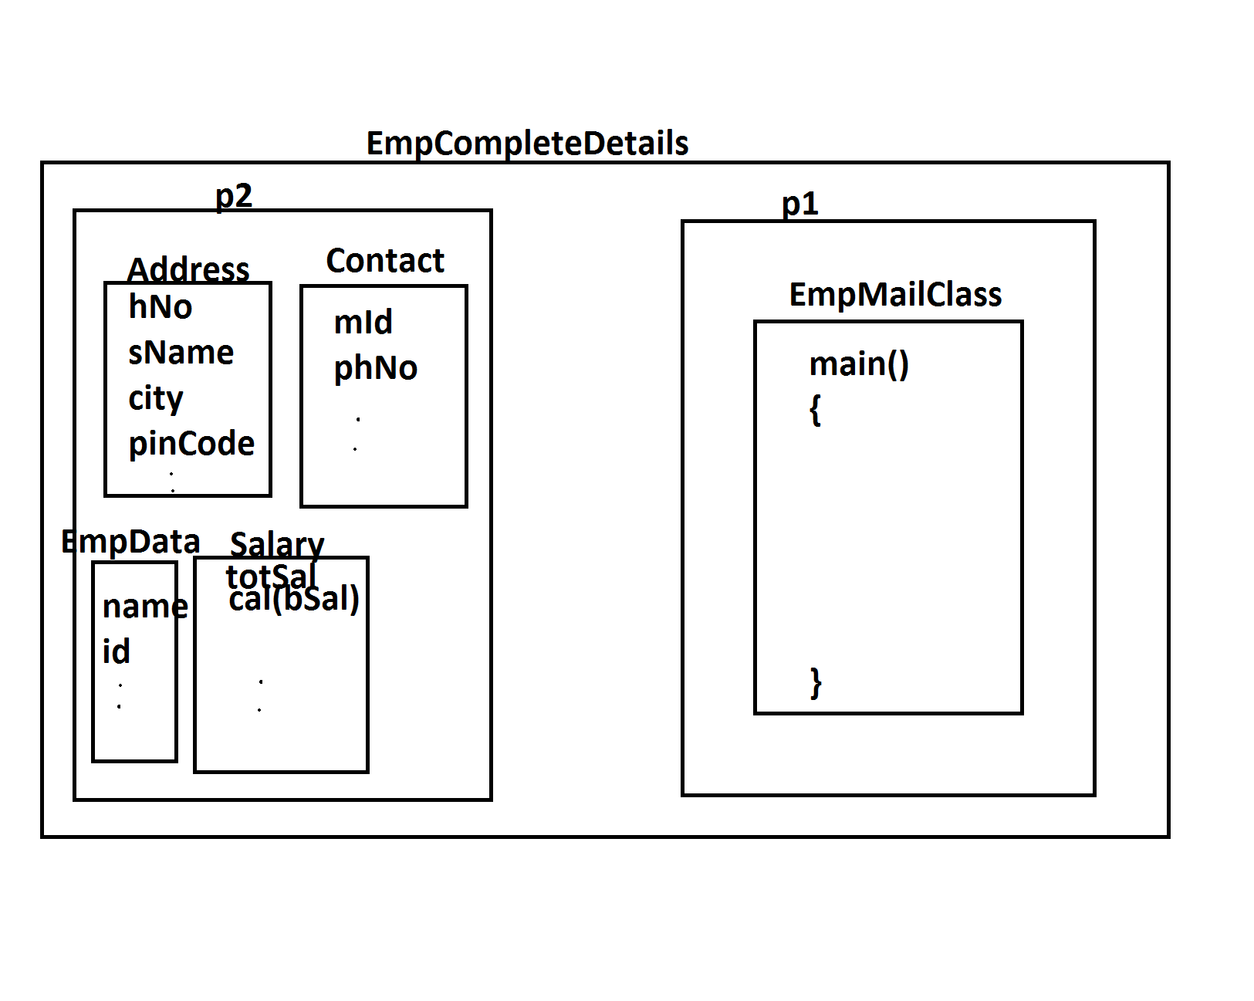

***p1 : EmpMainClass***

***p2 : EmpData,Address,Contact,Salary***

***EmpMainClass.java***

***package p1;***

***import java.util.Scanner;***

***import p2.EmpData;***

***import p2.Address;***

***import p2.Contact;***

***import p2.Salary;***

***public class EmpMainClass {***

***public static void main(String[] args) {***

***Scanner s = new Scanner(System.in);***

***EmpData ed = new EmpData();***

***Address ad = new Address();***

***Contact cn = new Contact();***

***Salary sl = new Salary();***

***System.out.println("Enter the EmpId:");***

***String eId = s.nextLine();***

***System.out.println("Enter the EmpName:");***

***String eName = s.nextLine();***

***ed.setEmpData(eId, eName);//Setting the data to object***

***System.out.println("Enter the hNo:");***

***String hNo = s.nextLine();***

***System.out.println("Enter the SName:");***

***String sName = s.nextLine();***

***System.out.println("Enter the City:");***

***String city = s.nextLine();***

***System.out.println("Enter the PinNo:");***

***int pinNo = Integer.parseInt(s.nextLine());***

***ad.setAddress(hNo, sName, city, pinNo);***

***//Setting the data to Object***

***System.out.println("Enter the MailId:");***

***String mId = s.nextLine();***

***System.out.println("Enter the PhNo:");***

***long phNo = s.nextLong();***

***cn.setContact(mId, phNo);//Setting the data to Object***

***System.out.println("Enter the bSal:");***

***int bSal = s.nextInt();***

***sl.calculate(bSal);***

***float tS = sl.getTotSal();***

***ed.getEmpData();***

***ad.getAddress();***

***cn.getContact();***

***System.out.println("====Salary====");***

***System.out.println("BSal:"+bSal);***

***System.out.println("TotSal:"+tS);***

***s.close();***

***}***

***}***

***EmpData.java***

***package p2;***

***public class EmpData {***

***public String id,name;***

***public void setEmpData(String a,String b)***

***{***

***id=a;***

***name=b;***

***}***

***public void getEmpData()***

***{***

***System.out.println("====EmpData====");***

***System.out.println("Id:"+id);***

***System.out.println("name:"+name);***

***}***

***}***

***Address.java***

***package p2;***

***public class Address {***

***public String hNo,sName,city;***

***public int pinCode;***

***public void setAddress(String a,String b,String c,int d)***

***{***

***hNo=a;***

***sName=b;***

***city=c;***

***pinCode=d;***

***}***

***public void getAddress()***

***{***

***System.out.println("====Address=====");***

***System.out.println("HNO:"+hNo);***

***System.out.println("SName:"+sName);***

***System.out.println("City:"+city);***

***System.out.println("PinCode:"+pinCode);***

***}***

***}***

***Contact.java***

***package p2;***

***public class Contact {***

***public String mId;***

***public long phNo;***

***public void setContact(String a,long b)***

***{***

***mId=a;***

***phNo=b;***

***}***

***public void getContact()***

***{***

***System.out.println("====Contact====");***

***System.out.println("MId:"+mId);***

***System.out.println("PhNo:"+phNo);***

***}***

***}***

***Salary.java***

***package p2;***

***public class Salary {***

***public float totSal;***

***public void calculate(int bSal)***

***{***

***totSal = bSal+(0.93F*bSal)+(0.63F*bSal);***

***}***

***public float getTotSal()***

***{***

***return totSal;***

***}***

***}***

***o/p:***

***Enter the EmpId:***

***A121***

***Enter the EmpName:***

***Raj***

***Enter the hNo:***

***12-34/h***

***Enter the SName:***

***SrNagar***

***Enter the City:***

***Hyd***

***Enter the PinNo:***

***612345***

***Enter the MailId:***

***raj@gmail.com***

***Enter the PhNo:***

***9898981234***

***Enter the bSal:***

***120000***

***====EmpData====***

***Id:A121***

***name:Raj***

***====Address=====***

***HNO:12-34/h***

***SName:SrNagar***

***City:Hyd***

***PinCode:612345***

***====Contact====***

***MId:raj@gmail.com***

***PhNo:9898981234***

***====Salary====***

***BSal:120000***

***TotSal:307200.0***

***===========================================================***

***Assinment:***

***Construct Application for StudentCompleteDetails.***

***Layout:***

